Given the provided data, what are three conclusions we can draw about Kickstarter campaigns?

* Data was based of 4,000 projects, the findings showed
  + the category music produced the greatest percentage of successful campaigns with a 77% success rate and a 17% failed rate.
  + Within the music category rock music had the greatest success

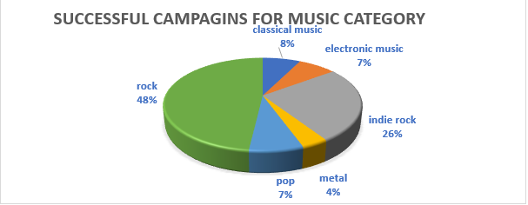

* + The greatest number of campaigns on Kickstarter is theater with a success rate of 60% and a failure rate of 35%, where plays have the highest success rate of all sub-categories.
  + 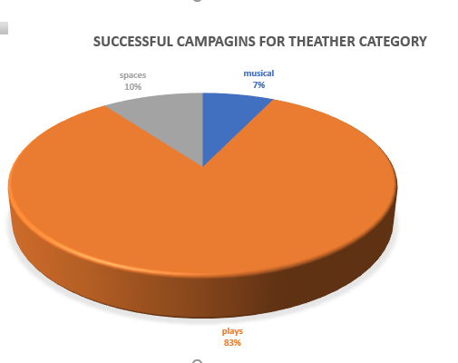
  + Journalism is the only campaign with a 100% canceled rate

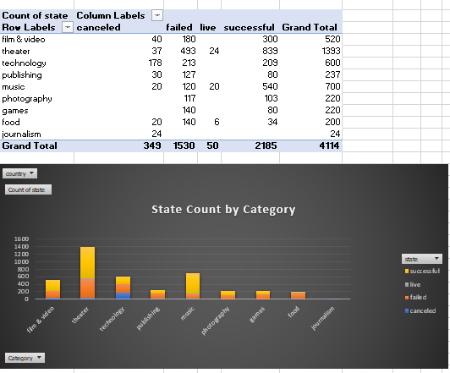

* + The best month to start a campaign is May and the worst month is December as it had the lowest percentage of success.
  + Statistical analysis showed that failed campaigns have a lot more outliers than successful campaigns and the more backers a campaign had the greater the success rate.

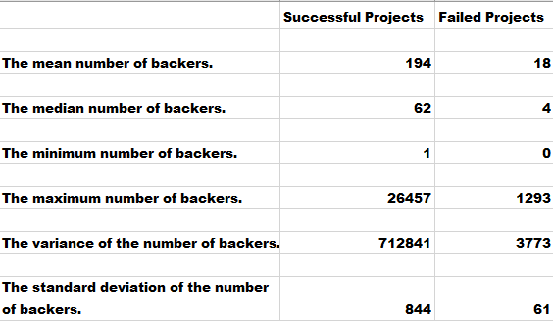

What are some limitations of this dataset?

Limitations to this dataset are:

* + 1. How was the sample size selected: random or Top 10% etc. The method in which the sample population was selected can present misleading results.
    2. There is not enough data to explain why projects were canceled.
    3. Were the goals set per project realistic goals for the project and demographic?

What are some other possible tables and/or graphs that we could create?

As shown above, other possible graphs/charts/tables that would be created from using this dataset are pie graphs to display the percentages of various categories or subcategories, scatterplots and box and whiskers to visualize the statistical data and using splicers to further analyze the data.